Ideation Phase
Brainstorm & Idea Prioritization Template

Date | 2 November 2025
Team ID | NM2025TMID08137
Project Name | Educational Organisation Using ServiceNow
Maximum Marks | 4 Marks

Brainstorm & Idea Prioritization Template:
Educational Organization using ServiceNow Template:
Overview:
This guided project focuses on creating a centralized Educational Organization Management System using the ServiceNow platform. The primary goal is to digitize and automate academic operations such as student registration, faculty management, course tracking, and feedback collection — all within a unified system.
This brainstorming and idea prioritization framework helps teams collaborate effectively, unleash creativity, and develop structured concepts, even when working remotely.
Reference: https://www.mural.co/templates/brainstorm-and-idea-prioritization
Step 1: Team Gathering, Collaboration, and Problem Statement Selection
Team members collaborated to pinpoint real-world challenges faced by educational institutions.
The selected problem statement was:
“How can we digitally manage an institution’s academic and administrative workflows using ServiceNow?”
The discussion highlighted the need for a unified platform that enables smooth interaction between students, faculty, and administrators, enhancing overall efficiency and user experience.
Reference:https://www.mural.co/templates/brainstorm-and-idea-prioritization

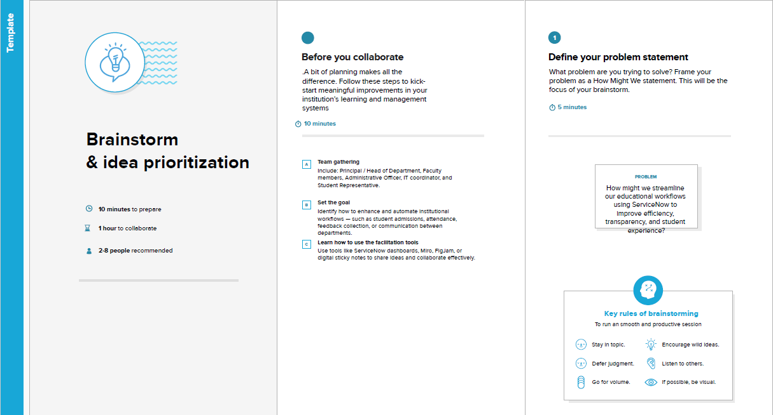

Step 2: Brainstorming, Idea Listing, and Grouping
Brainstorm:
The team explored the major difficulties educational institutions encounter in managing academic and administrative activities. The focus was on leveraging ServiceNow tools such as Flow Designer, Catalog Items, and Workflows to drive automation, accountability, transparency, and efficiency.
Idea Listing:
During brainstorming, several innovative ideas emerged, including:
- Automating the student admission and approval process.
- Assigning academic and administrative responsibilities based on staff specialization.
- Tracking course schedules, exam duties, and student service requests.
- Simplifying feedback collection to promote transparency and continuous improvement.
Grouping:
The ideas were categorized into four major clusters:
- Cluster 1: Automate student admission workflows using ServiceNow forms and real-time approval mechanisms.
- Cluster 2: Assign academic and administrative tasks based on staff roles, departments, and expertise to enhance accountability.
- Cluster 3: Track workloads such as course scheduling, exam duties, and student requests using dashboards and analytics.
- Cluster 4: Strengthen transparency and operational efficiency through simplified internal workflows and structured feedback systems.
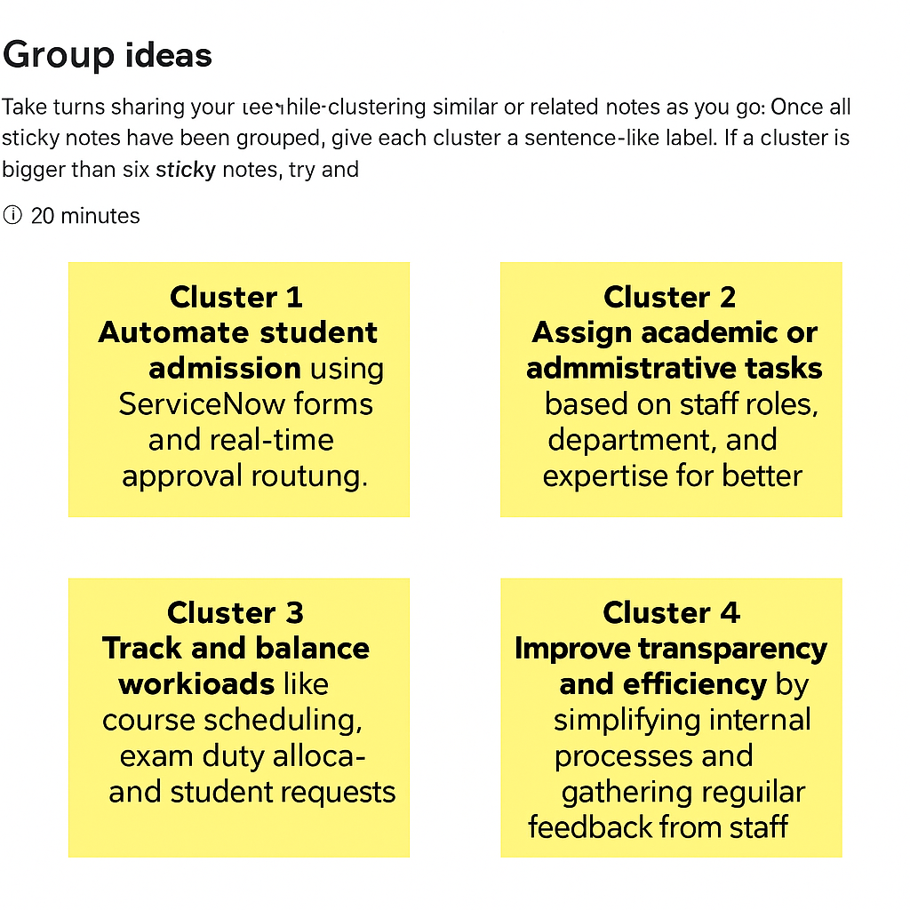

Step-3: Idea Prioritization
The prioritization phase emphasized implementing the most impactful and foundational modules first — namely, Student Management and Course Management. These serve as the core of the educational management ecosystem.
This structured prioritization ensures a gradual rollout of additional features like feedback automation, performance tracking, and analytics dashboards. Visual aids and flow diagrams will be used to maintain clarity during development and foster effective stakeholder communication.
By organizing ideas based on educational relevance, technical feasibility, and user impact, the project sets a clear path toward building a comprehensive, digital educational management platform using ServiceNow.

